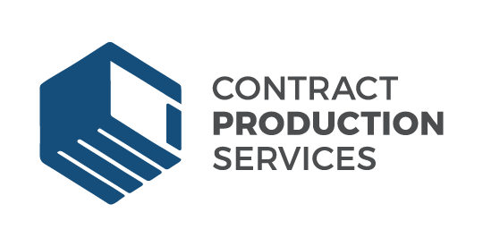

Contract Production Services

Contract Production Services is one of the most trusted co-packing companies, providing superior display and retail packaging services. Founded in 1955, our mission is to provide our customers with fast-turn, high-quality contract packaging solutions and ensure we exceed their production goals. Contract Product Services is the preferred choice for companies needing flexible, knowledgeable quality partners to deliver their contract packaging needs. We have experience assembling the best display and retail packaging for all types of products.

Job Title: Senior Production Planner

Position Summary:
Senior Production Planner is responsible for planning production projects, implementation, and delivery per customers’ specifications.

Job Type: Full-time with benefits

Salary: $74,000-$80,000

Attributes:
- Exceptional customer service
- Flexible and adaptable to changing production requirements
- Ability to remain calm when working under stress or pressure
- Focus on safe work habits throughout all work activities
- Initiative and a commitment to ongoing improvement

Key Result Areas:
The primary accountabilities for the position include:

Manage specific projects, production planning, and operations
- Set operational, production and maintenance planning priorities including planning, scheduling and coordinating department activities to fulfill sales orders, inventory requirements and delivering products timely.
- Project management may require purchasing of materials and supplies, budget tracking, employee training, startup of projects and oversight of specific processes.
- Ensure productivity and quality performance standards are met or exceeded.

- Quality Control
- Coordinate product transitions.
- Maintain current pack standards as provided by customers.

- Manage materials and Logistics
- Plan and manage production schedules to meet customer delivery requirements and best use of company capacity.
- Responsible for analysis of customer orders with respect to capacity planning and material requirements.
- Responsible for the management of inventory levels, schedules, and availability of selected items to meet production schedules.

- Coordinate purchasing for assigned production line.
- Ensure adequate materials are available.
- Deliver exceptional customer service.
- Enter customer orders in customer systems (e.g., MIRS, if applicable), verify pricing and product match customer’s purchase order, work closely with customer’s staff to plan orders and ensure products are created to customer specification.
- Advise customers of any changes to the production schedule, create bills of lading and ship notices in customers’ computer system (USS system), provide inventory report to customer on a weekly basis.
- Create and maintain a strong relationship with customers’ staff and ensure timely response to all customer inquiries.

- Manage and Develop Staff Members
- Recruit, retain and develop employees that positively contribute to the mission and values. Be approachable and available to employees’ questions and concerns.
- Work with employees to identify development needs and create growth opportunities.
- Supervise production operations directly and through production leadership, and use continuous improvement methods toward performance excellence.
- Ensure a safe work environment for staff
- Follow safety rules every time and ensure employees maintain compliance with safety rules.
- Identify and rectify potential unsafe conditions.
Physical Demands:
- The physical demands are those of a typical production environment.
- Ability to work on ladders, scaffolding or other work at heights.
- Ability to move about or to a work site by stooping, bending, kneeling or squatting frequently. May also require periods of prolonged sitting or standing.

Education and Experience:
- Eight years’ production planning and operations experience.
- Good written and verbal commutation skills are a must!
- Project management experience, concern for quality, and strong dedication to safety.
- Proven leadership, demonstrated problem solving skills, and ability to lead personnel and work closely with all departments.
- Must possess solid analytical skills to forecast and anticipate production needs and capabilities based on customer demand changes.
- Experience working with diverse populations is preferred. Spanish language abilities desirable.
- Prior experience with MAX, or comparable, MRP system.
- Excellent Excel skills.

To apply, please send your cover letter and resume to hr@contactcps.com.

